**Environments**

* **Virtual boxes environment setting is shown below**

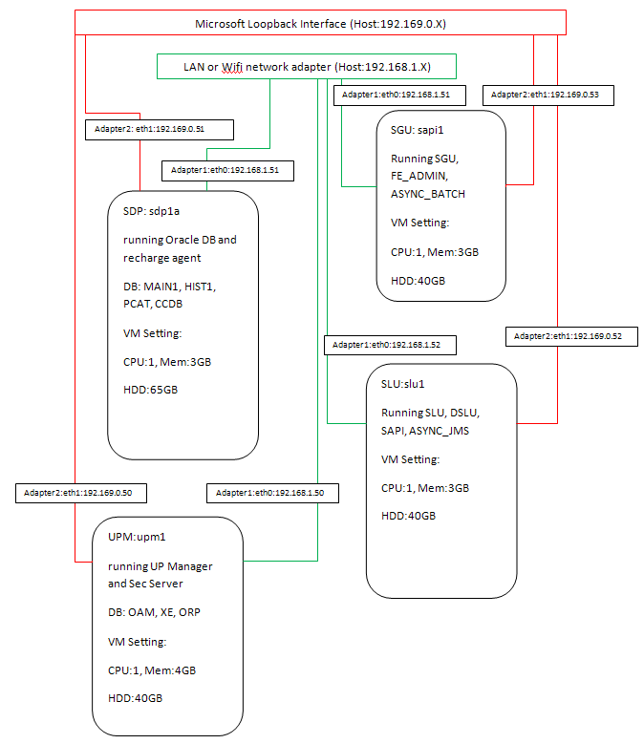

* **Desktop (192.168.1.X) – Host Machine**
  + User/Password (nontar/comverse)
  + Team viewer (710 704 614/comverse)
  + UPM Virtual Box (192.168.1.50, 192.169.0.50)
    - User/Password (root/Sonora)
  + SLU Virtual Box (192.168.1.52, 192.169.0.52)
    - User/Password (sncpuser/sncpuser)
  + Laptop image (Tools) (192.168.1.20, 192.169.0.20)
    - User/Password (comverse/comverse)
    - CCC (Customer Care Client)
      * User/Password (cccuser2/passw0rd)
    - PCAT (Product Catalog)
      * User/Password (pcuser2/pa$$word)
    - Voucher Tools
      * Card Generator
        + User/Password (comverse/comverse)
      * Encryption/Description Tools
    - CAP Call Simulator
    - JMETER Simulator
      * SMS via Diameter DCI
      * Data via Diameter PS
    - Subscriber provisioning (off line/batch provisioning) via the perl
    - SMS notification engine via the perl
    - Putty application (Remote console)
    - CAP Tracing information
    - DCI Tracing information
    - DPS Tracing information
    - SAPI Tracing information

* **Telephone number prefix**
  + 6686 – will be used on C1-RT
    - 6686-815-4011 -- 6686-815-4019 for Demo prepaid
    - 6686-815-4020 – 6686-815-4029 for CAT_Prepaid

**System Management**

* **Boot up sequence**
  + Run virtual box on Desktop
    - Start the SDP
    - Start the UPM
  + Run virtual box on Desktop
    - Start the SGU
    - Start the SLU
  + Run virtual box on Desktop
    - Start the XP image (Tools)
  + Once all 4 Virtual box images are up and running
    - Go to UPM as root
    - Run the following script “./rstart all”
* **Shutdown sequence**
  + Check if all 4 Virtual box images are up and running
    - Go to UPM as root
    - Run the following script “./rstop all”
  + Once all image are down, close the virtual boxes

**Operations**

* **Subscriber creations (basic subscribers)**
  + Log on at the CCC
  + Choose create-subscribers
  + Chose basic details
    - Fill in currency code
    - Choose offer
    - Choose manage external ID
    - Fill in Subscriber ID
    - Fill in IMSI ID

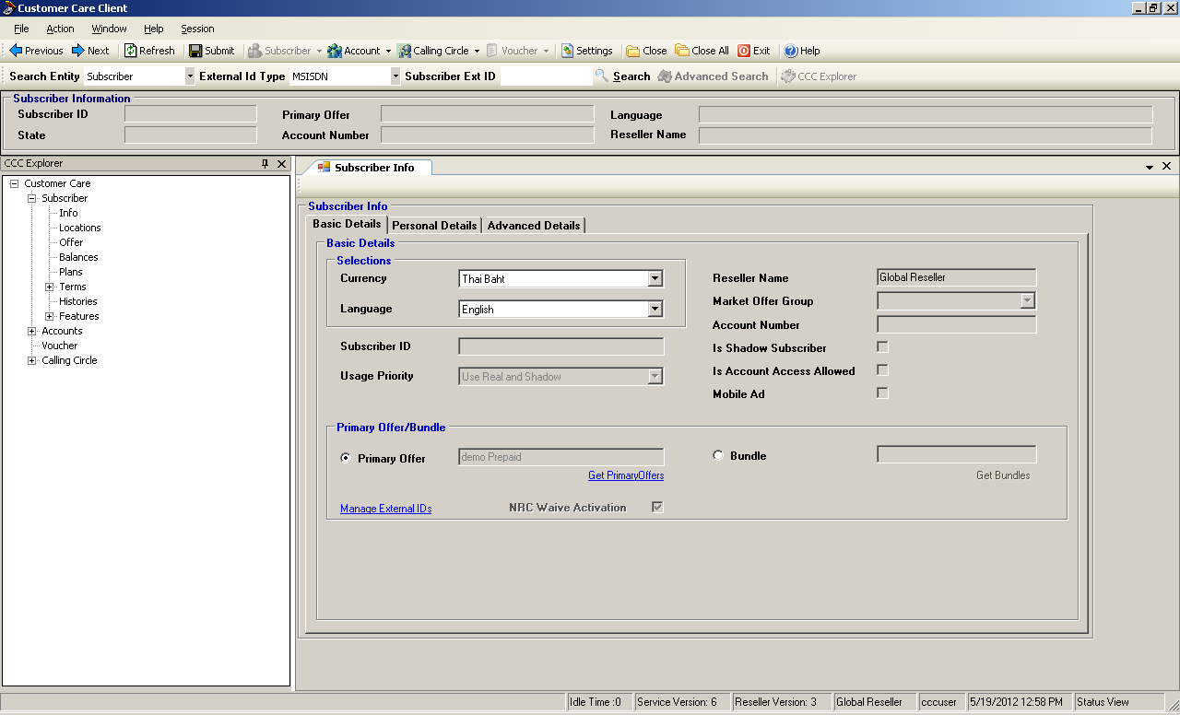

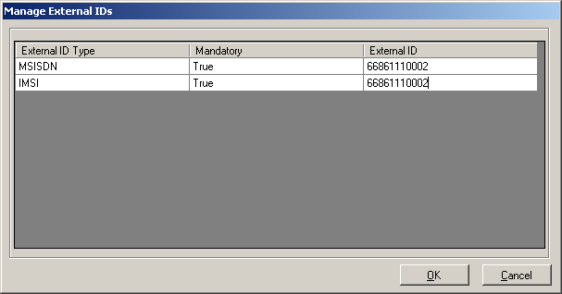

* + Choose personal detail
    - Update the country code
  + Choose advanced detail
    - Update time zone

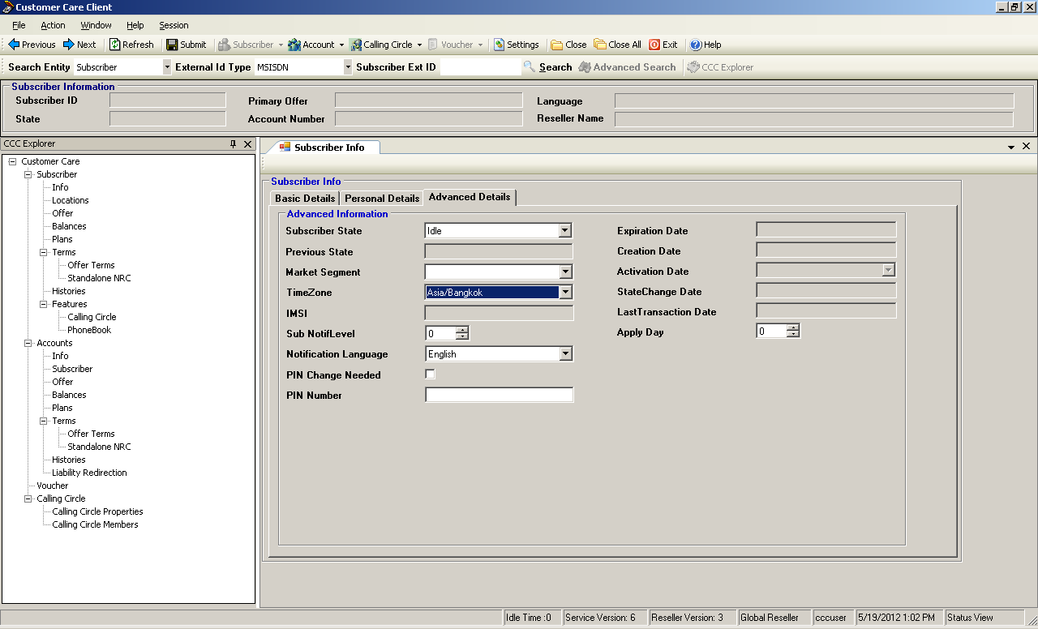

* **Account Subscriber creations (complex subscribers)**
  + Log on at the CCC
  + Choose account then create-account
    - Choose basic detail
      * Fill in account name
      * Fill in first name
      * Fill in last name
      * Fill in language
      * Fill in category

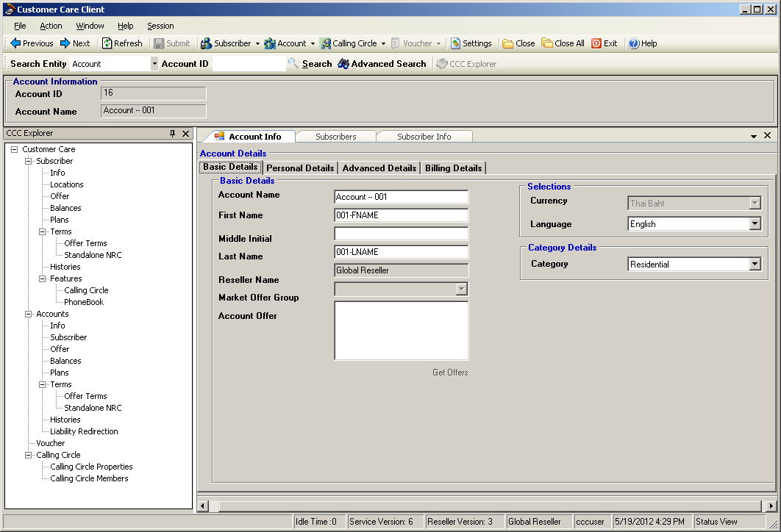

* + - Choose personal detail
      * Fill in country

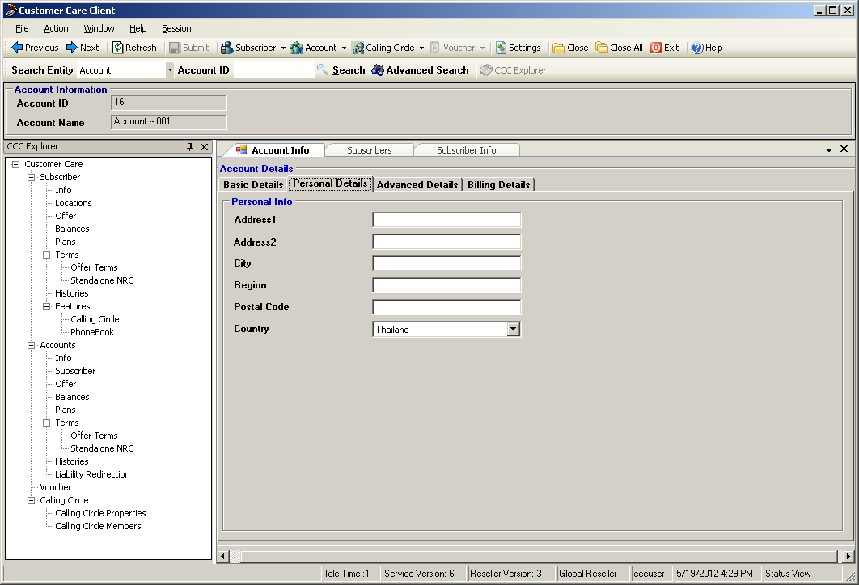

* + - Choose advanced details
      * Fill in time zone
      * Fill in active state

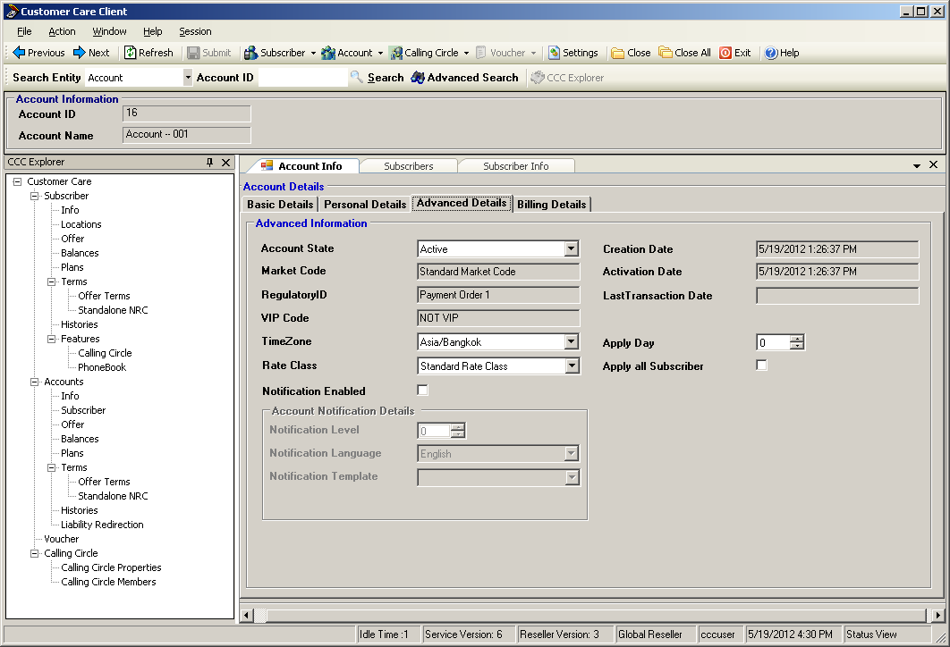

* + Add subscriber to account

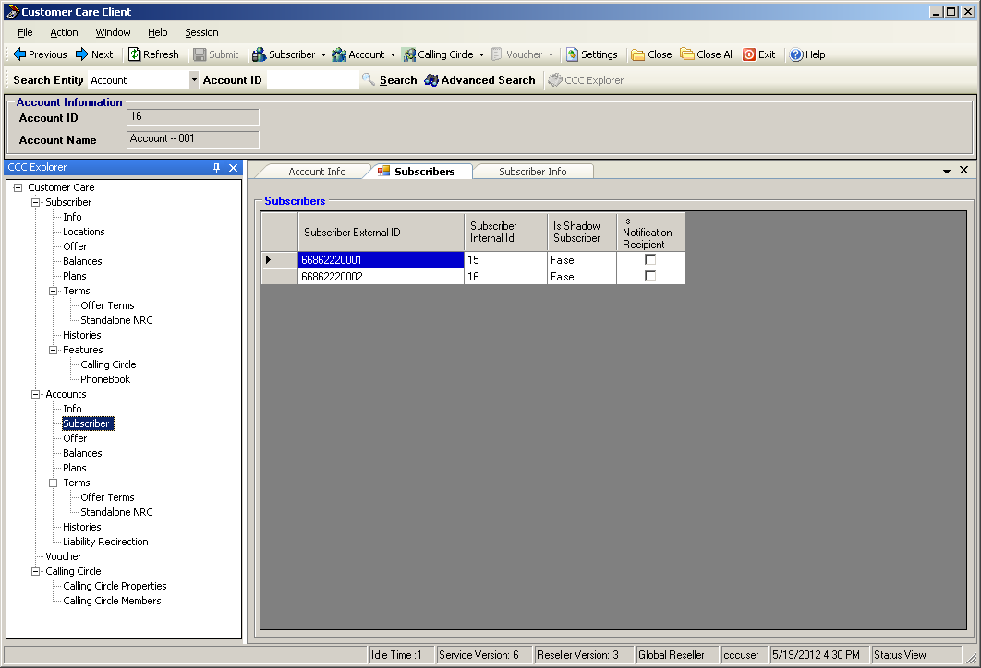

* + Choose account then create-subscribers
    - Chose basic details
      * Fill in currency code
      * Choose offer
      * Choose manage external ID
      * Fill in Subscriber ID
      * Fill in IMSI ID

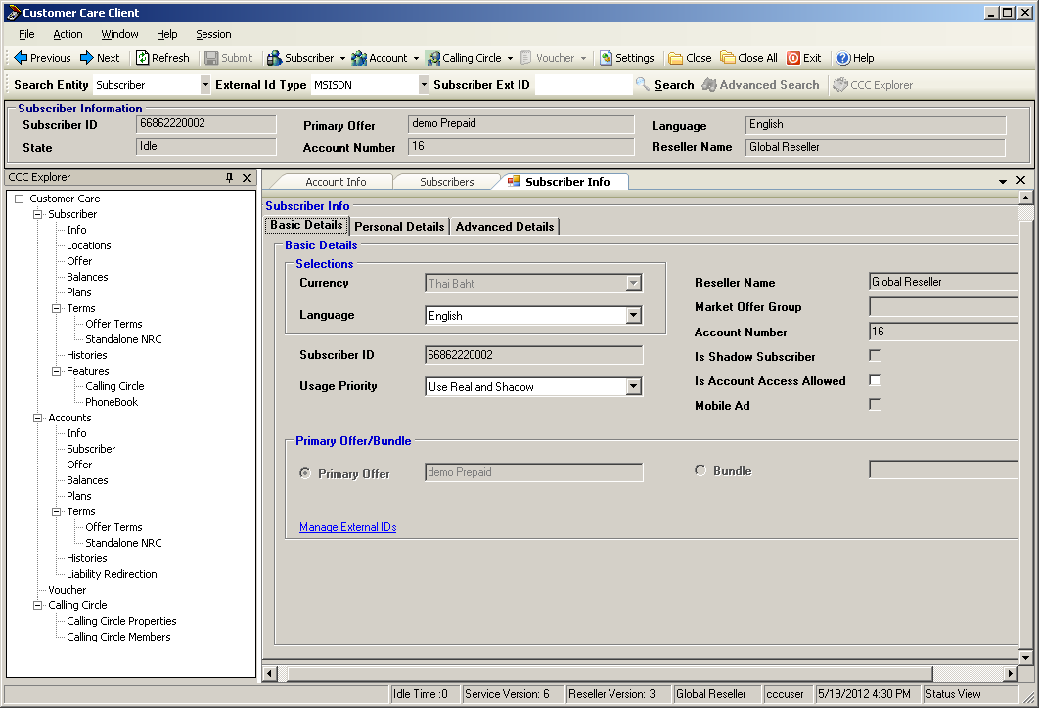

* + - Choose personal detail
      * Update the country code

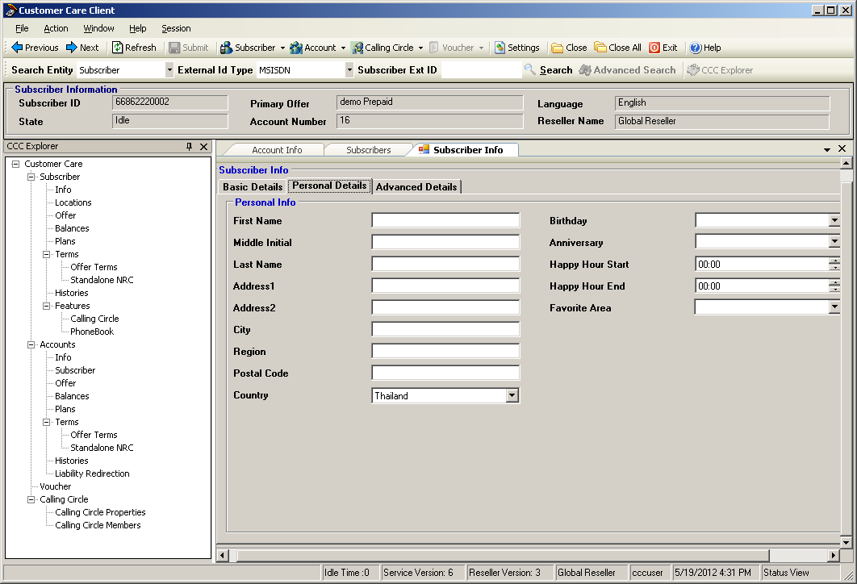

* + - Choose advanced detail
      * Update time zone

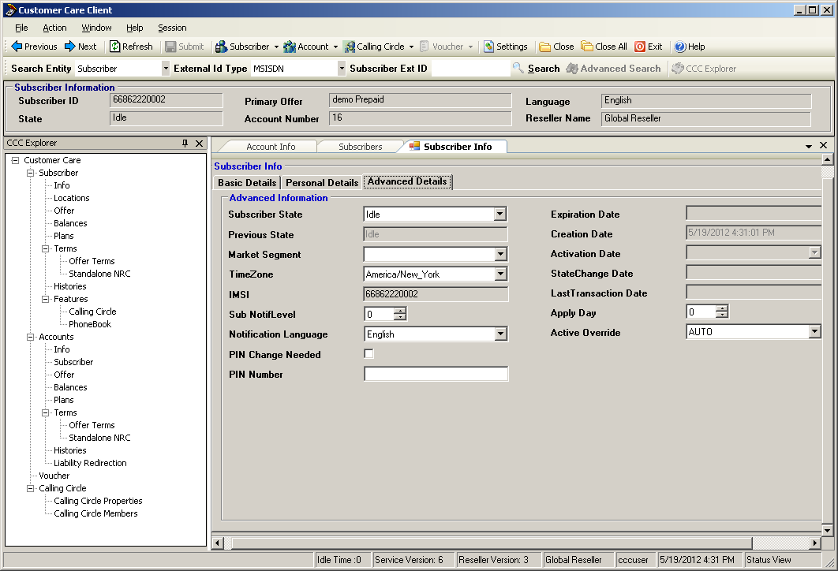

* **Subscribers balances & history**
  + For Voice, At CCC, use the balances/history option under the Subscriber

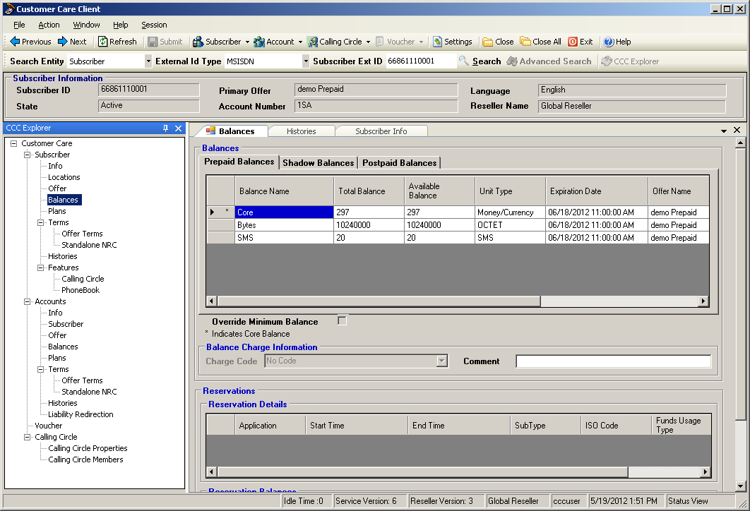

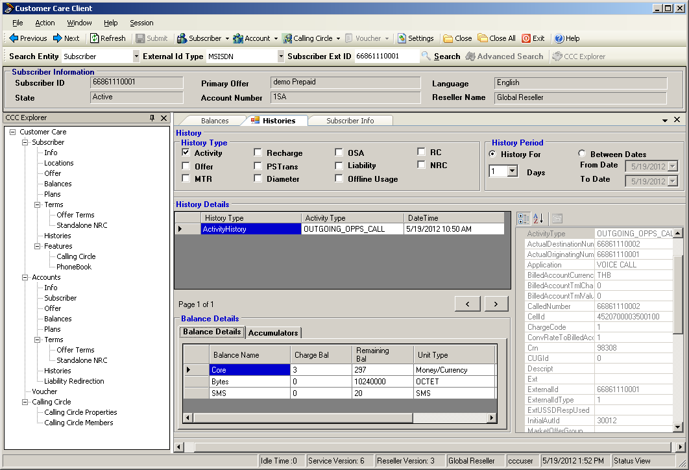

* + For SMS, At CCC, use the balances/history option under the Subscriber

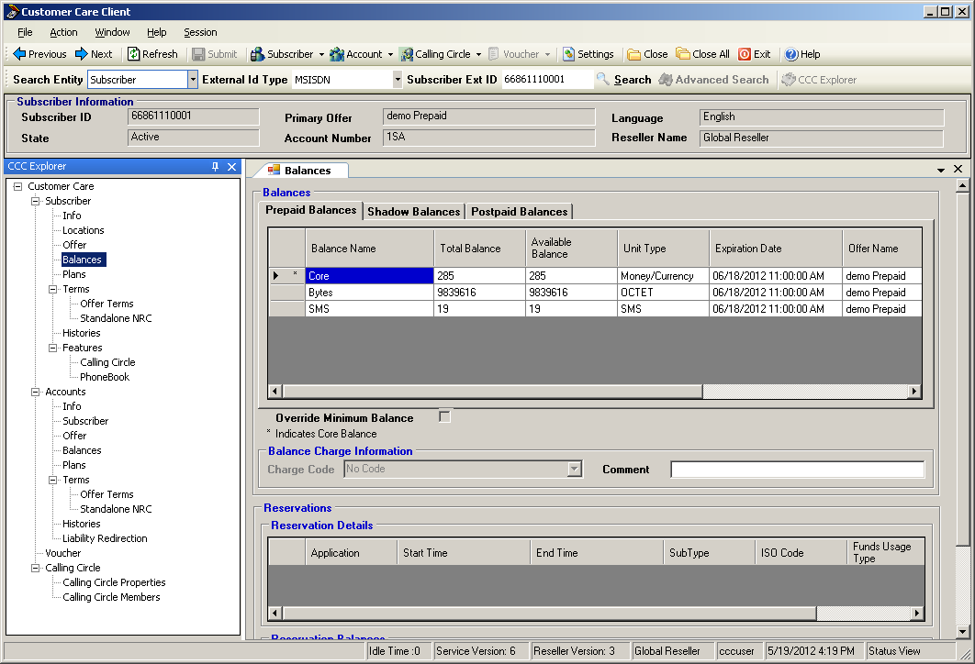

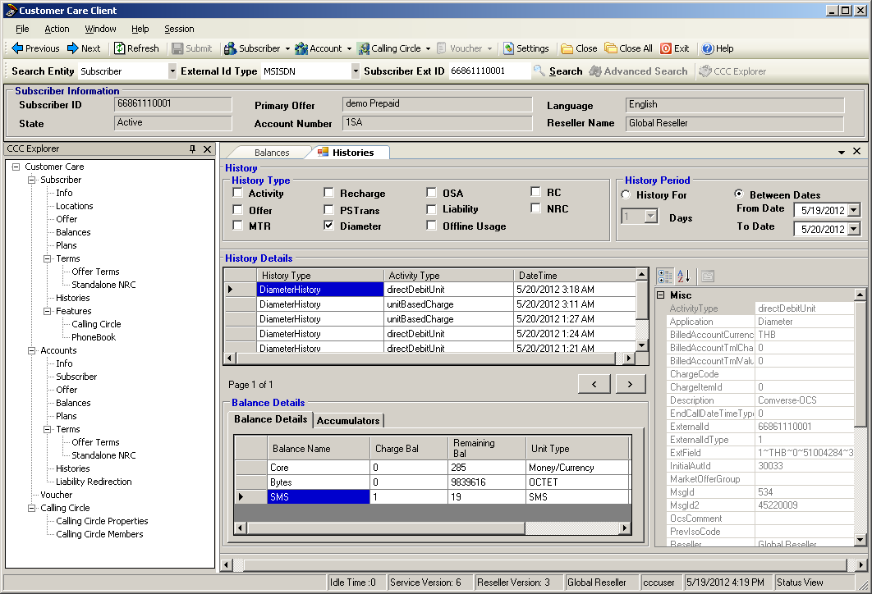

* + For Data, At CCC, use the balances/history option under the Subscriber

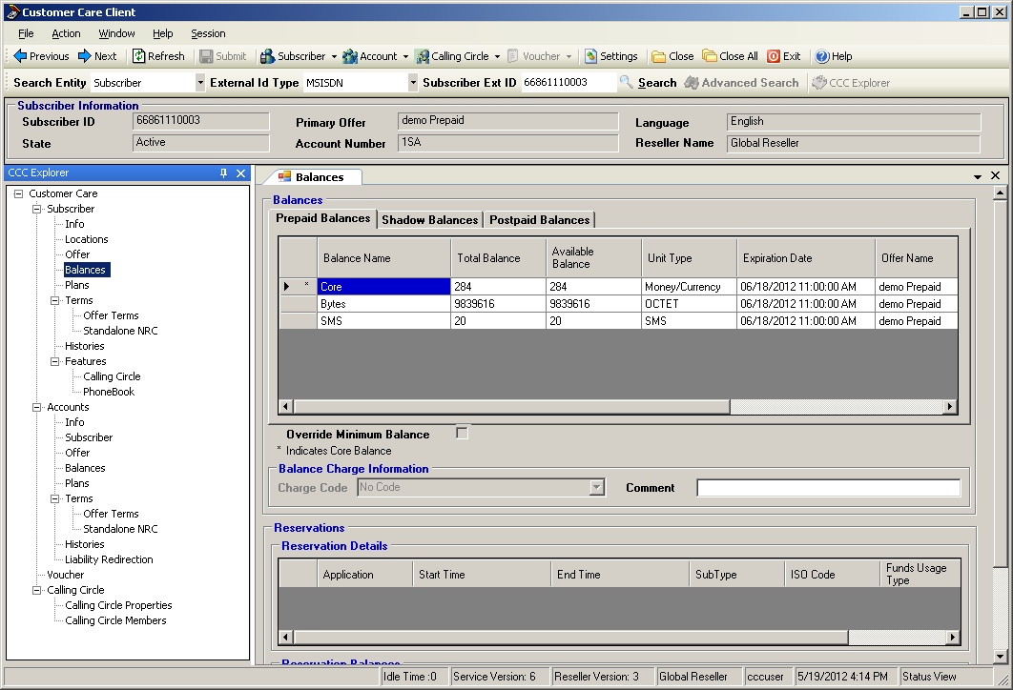

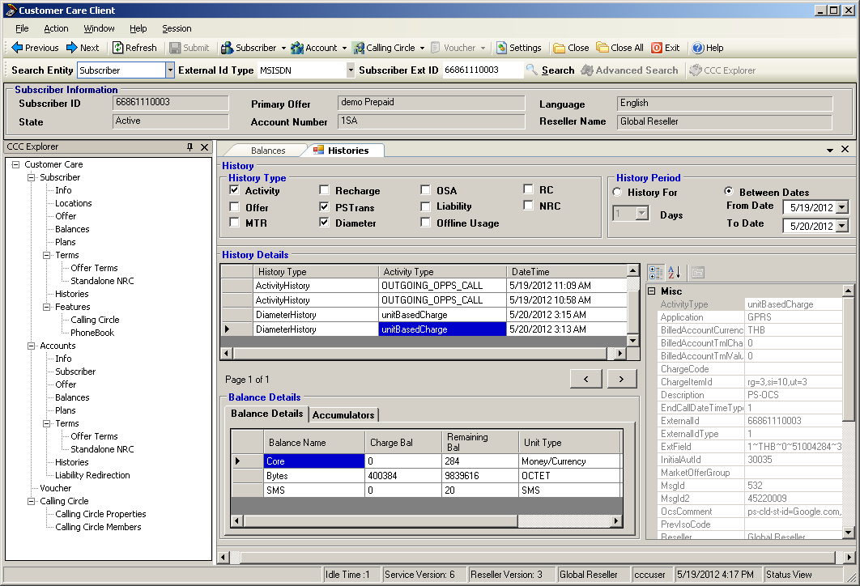

* **IPBill -- CDR** 
  + Logon at SLU as sncpuser/sncpuser
  + cd /data/slu1/CDR
  + Looking for IPbill*
  + Process to readable format by
  + #CDR_Post IPBill…. > CDR_Post_...txt

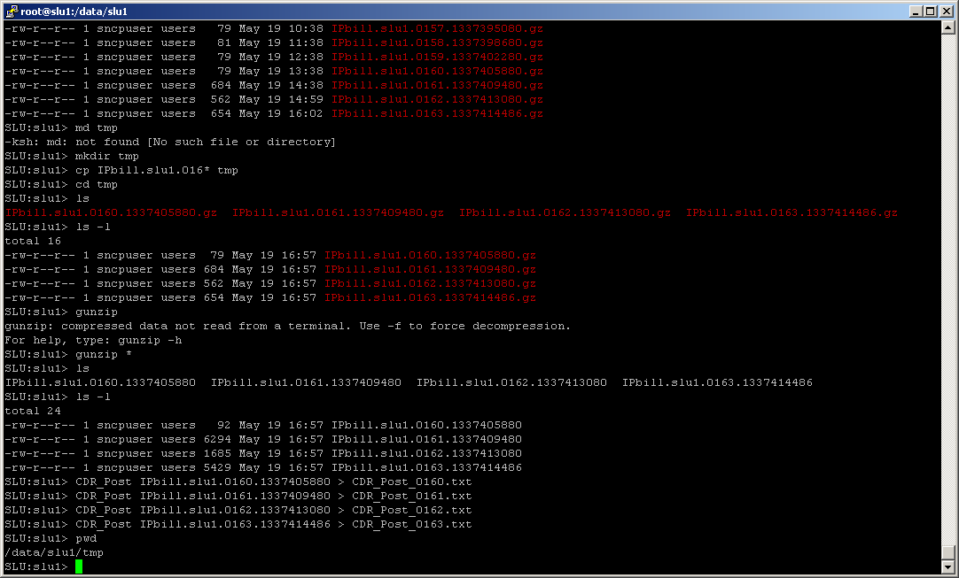

* **IPor – Offline record** 
  + Logon at UPM as root
  + cd ORP
  + prepare input file
    - Format : <a number>,<b number>,<duration>
    - Sample:
      * 6818154001,66818154011,30
      * 66818154002,66818154013,20
  + To generate ORP file , Run :  ./orgen <input filename>
  + To transfer IPor file to process : ./transfer <IPor filename>
  + cd /root
  + ./offline

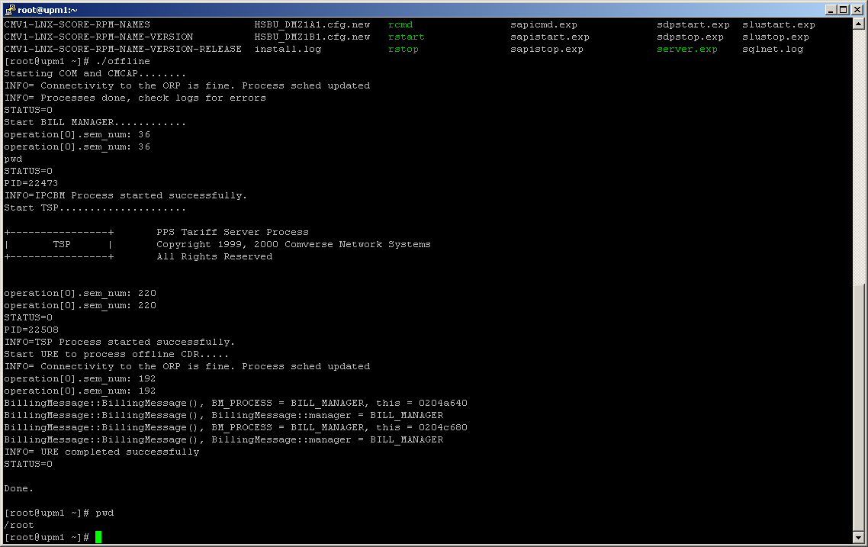

**Tracing**

* **Voice tracing**
  + Simulator is based on call simulator
    - Load the test environment
    - Edit the test plan

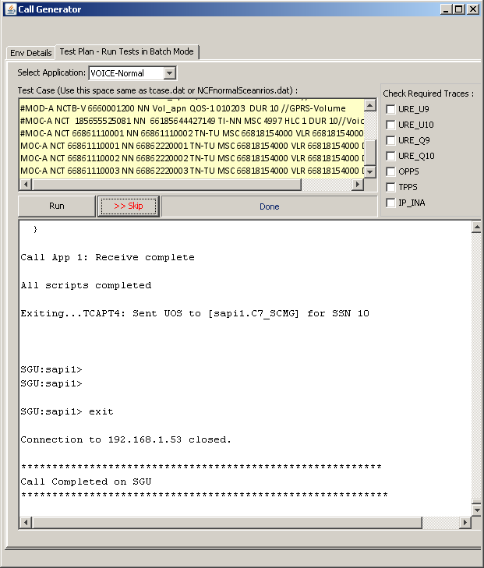

* **Diameter tracing**
  + SMS Simulator is based on JMETER
    - Load the test environment (D:\Simulator\Jmeter\test_plan\SMS.jmx)
    - Edit the subscriberid to prefer testing number

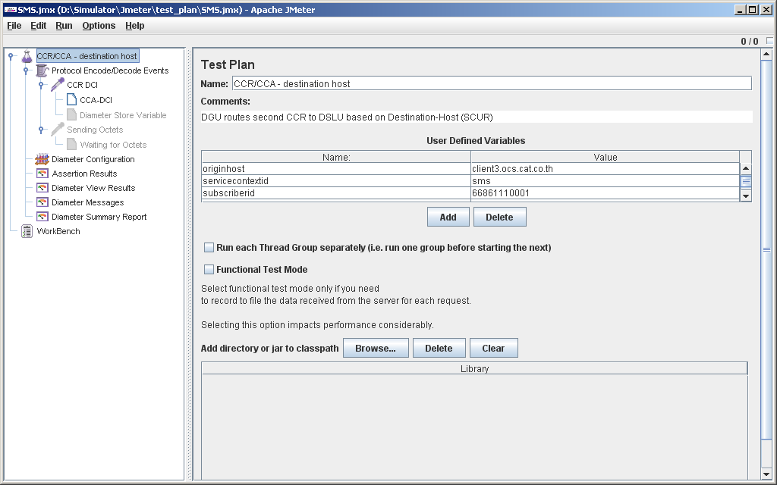

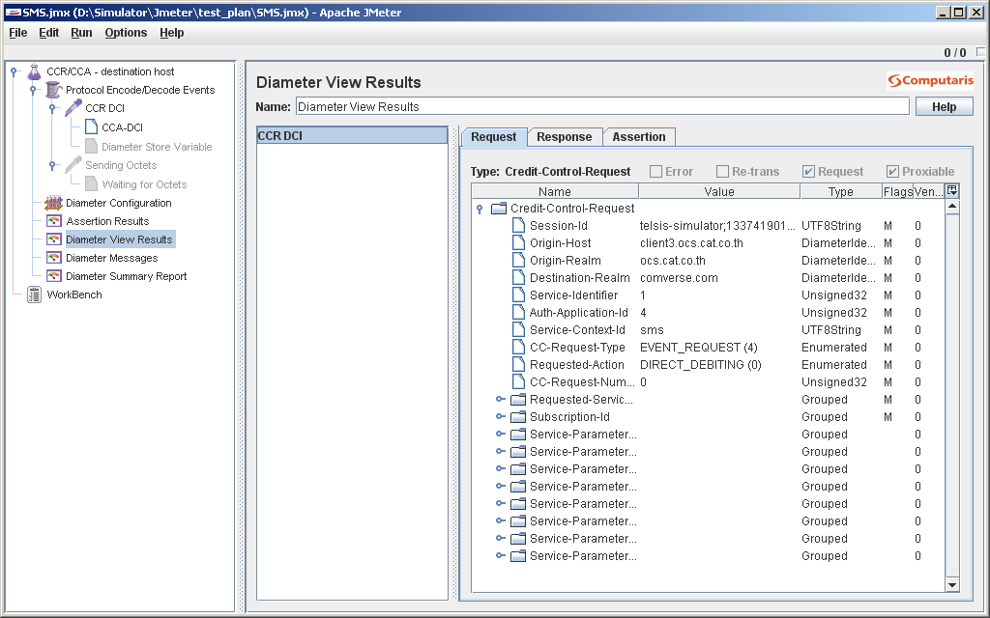

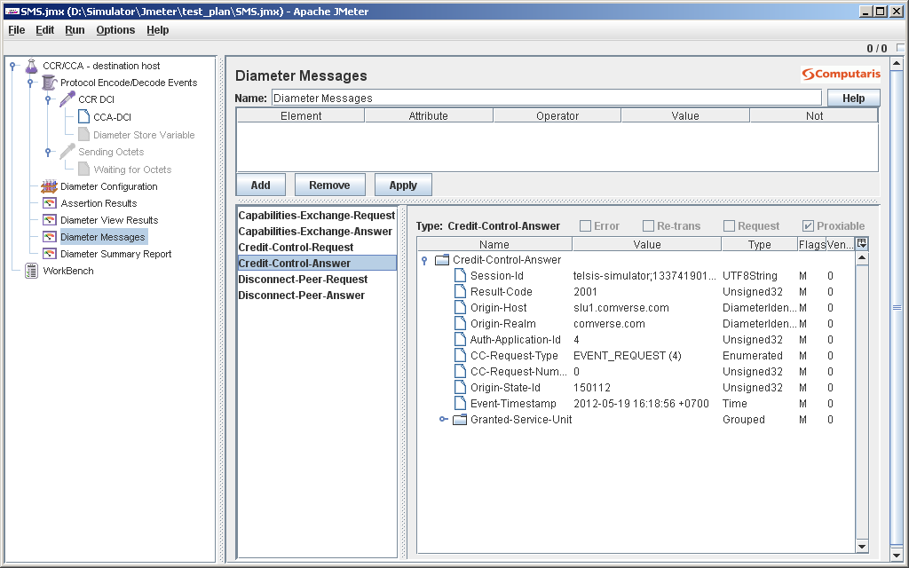



* + Data Simulator is based on JMETER
    - Load the test environment (D:\Simulator\Jmeter\test_plan\DATA.jmx)
    - Edit the subscriberid to prefer testing number

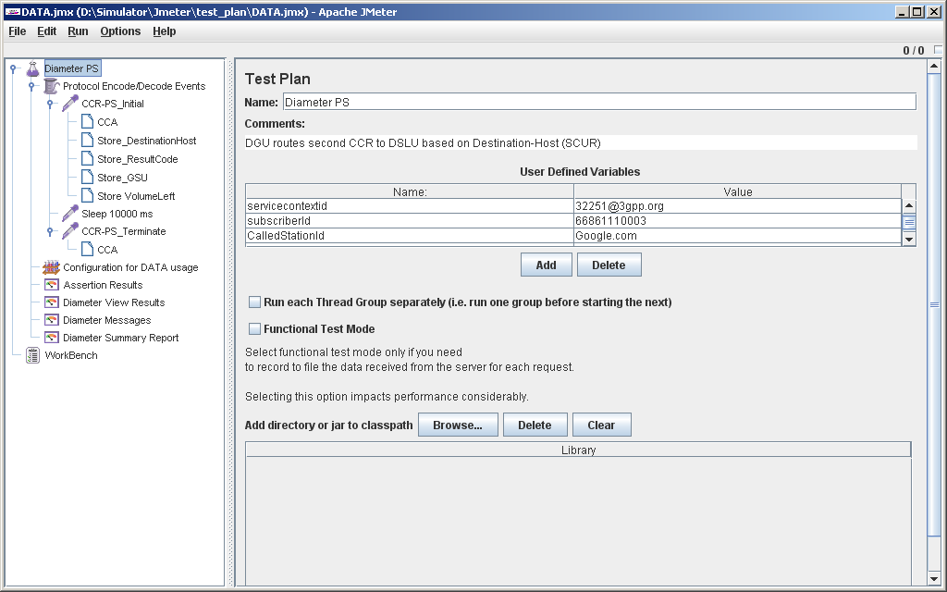

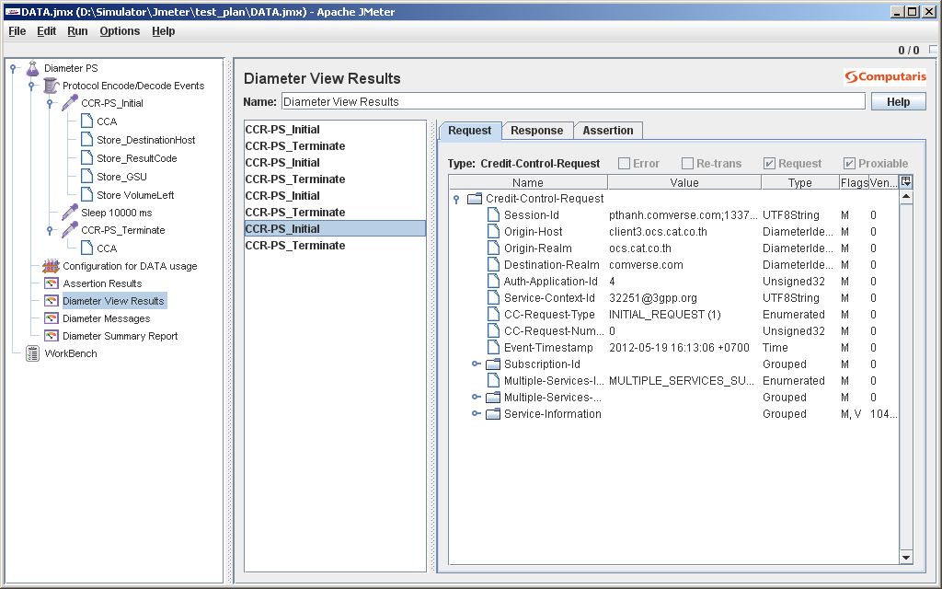

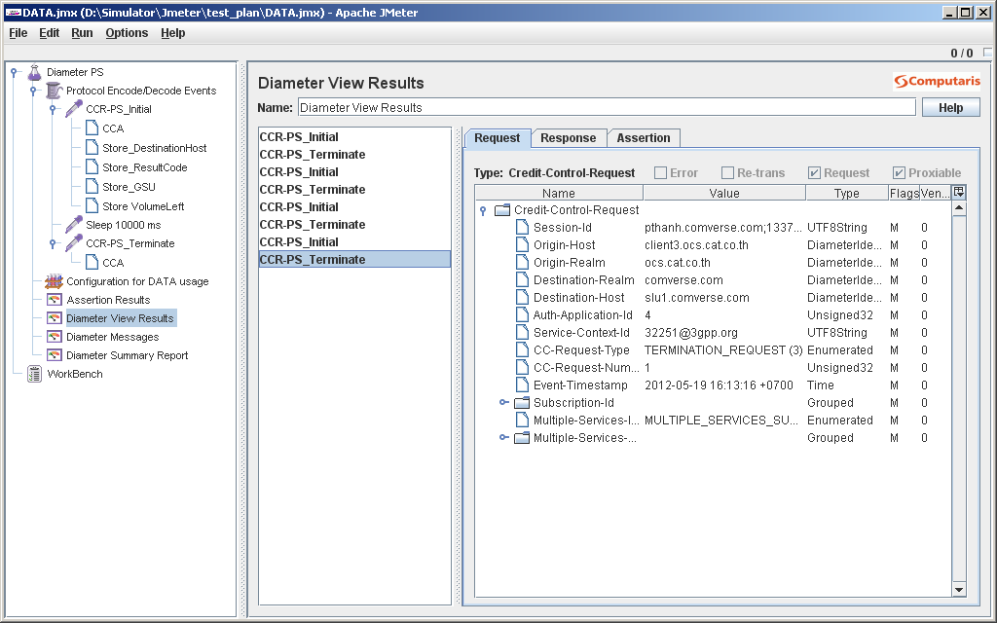

**Integration**

* **Rated CDR** 
  + Rated CDR from offline processing
    - The rated CDR file can be retrieved from
      * upm (192.168.1.50)
      * /data/upm1/IPbill*
    - The file transfer can be done via the following
      * sftp sncpuser/sncpuser
    - Please note that Avalant must have all necessary logic to check file sequence number. In this folder, Comverse will keep all of IPbill* then Avalant must have logic to check to retrieve only the new files. Avalant can’t delete any files in this folder. Sample file name are listed below
      * IPbill.upm1.0163.1337414486
      * IPbill.upm1.0164.1337418120
  + Rated CDR from online processing
    - The rated CDR file can be retrieved from
      * slu (192.168.1.52)
      * login as sncpuser/sncpuer
      * /data/slu1/CDR/IPbill*
    - The file transfer can be done via the following
      * sftp sncpuser/sncpuser
    - Please note that Avalant must have all necessary logic to check file sequence number. In this folder, Comverse will keep all of IPbill* then Elcom must have logic to check to retrieve only the new files. Sample file name are listed below
      * IPbill.slu1.0163.1337414486
      * IPbill.slu1.0164.1337418120
* **Offline rating**
  + This section show how the offline rating work and what need to be configured. It is based on the ORP process. Here are the steps
    - Logon the upm
    - cd ORP
    - vi orp-input.txt
      * The format are A-NUMBER, B-NUMBER, DURATION
      * The system will take the current system time for first transaction, then increase by duration of first transaction as start time of second transaction
    - ./orgen orp-input.txt
      * The orgen will generate the file of IPor.slu1.XXX.YYYYYYYY
    - ./transfer IPor.slu1.XXX.YYYYYYYY
    - cd
    - ./offline